# A REVIEW OF LIVER PATIENT ANALYSIS METHODS USING MACHINE LEARNING

1. INTRODUCTION:

* 1. Overview:

Liver diseases avert the normal function of the liver. This disease is caused by an assortment of elements that harm the liver. Diagnosis of liver infection at the preliminary stage is important for better treatment. In today’s scenario devices like sensors are used detection of infection.

Accurate classification techniques are required for automatic identification of disease samples. This disease is very costly and complicated.

1.2 Purpose:

Early prediction of liver disease using classification algorithms is an efficacious task that can help the doctors to diagnose the disease within a short duration of time.

2. PROBLEM DEFINITION & DESIGN THINKING:

2.1 Empathy map:

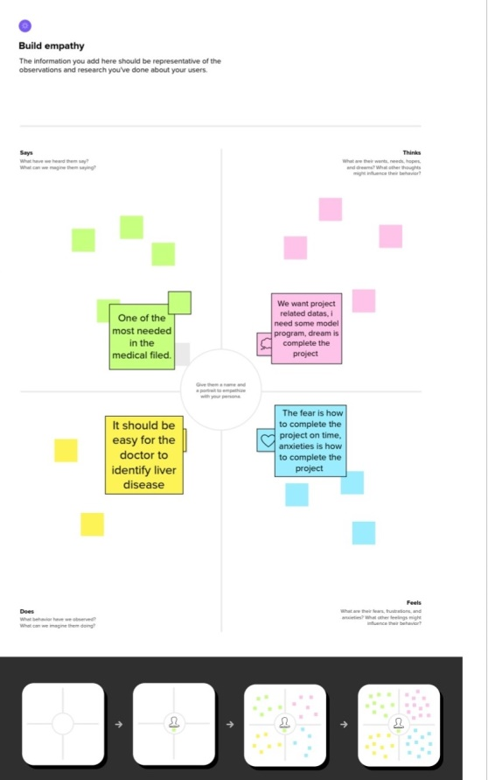

3. RESULT:

4. ADVANTAGE & DISADVANTAGE:

4.1 Advantage:

* Low cost and easy process.
* It’s very useful to the doctors for analysis the accurate problem
  1. Disadvantage:
* Take same time

5. APPLICATIONS:

6. CONCLUSION:

Since the liver disease is not easy to diagnose the delicate nature of its sighs, this research is patient in determining is patient algorithms the have better accuracy in predicting this dreadful disease.

7. FUTURE SCOPE:

The proposed liver disease prediction methods have provided right path the liver disease detection. User need to do pass the details being asked, which are already present in the blood test report (some like age, gender, are already known) and then user will get the result of prediction.

8. APPENDIX: